**DSA Assignment – 21th June**

**Name – Karan Joshi**

**Roll No. – 23/11/EC/036**

**Leetcode Id – Karan_Joshi068048**

**Geeksforgeeks Id – wwwjoshikaran3424**

**Github Repo Link -** [**https://github.com/KaranJoshi101/urban-octo-robot/**](https://github.com/KaranJoshi101/urban-octo-robot/)

DSA-Section -

Question 1: Minimize Size Subarray Sum

Platform: LeetCode

Problem Link: <https://leetcode.com/problems/minimum-size-subarray-sum/description/>

Submission Screenshot:

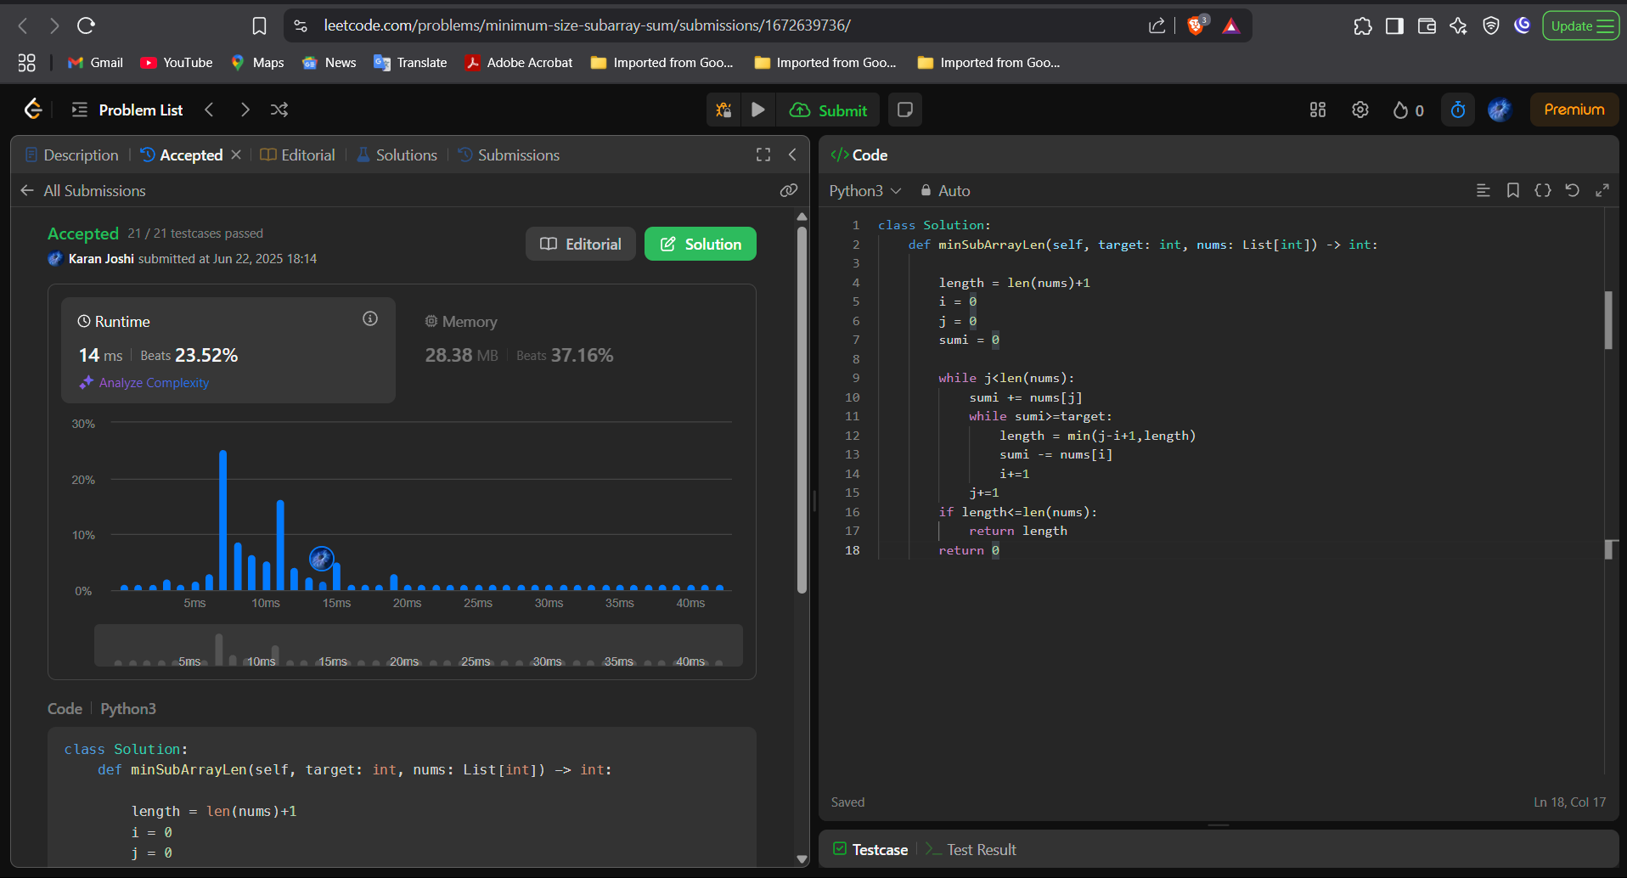

Question 2: Majority Element II

Platform: LeetCode

Problem Link: <https://leetcode.com/problems/majority-element-ii/>

Submission Screenshot:

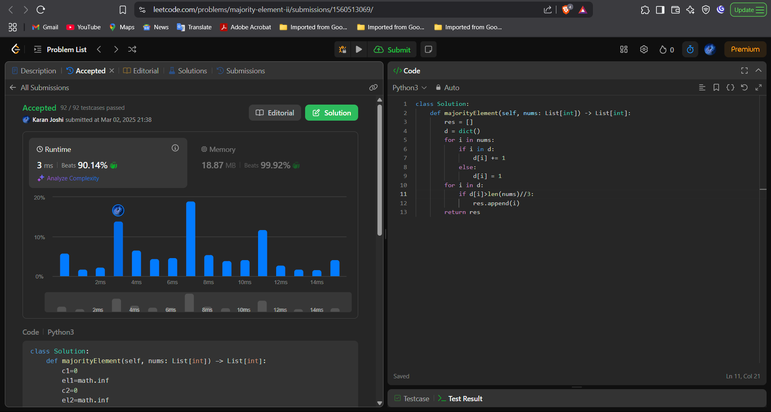

Question 3: Next Permutation

Platform: LeetCode

Problem Link: <https://leetcode.com/problems/next-permutation/description/>

Submission Screenshot:

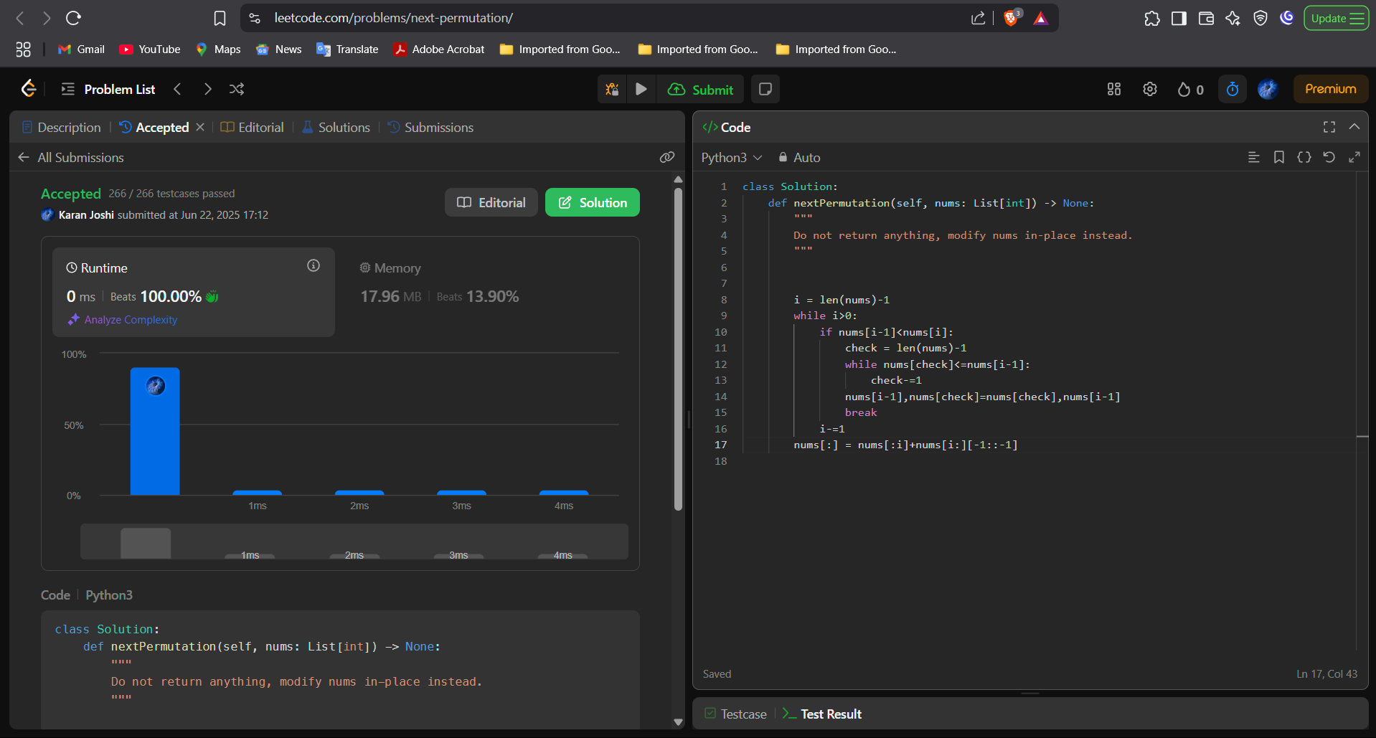



Question 4: Grumpy Bookstore Owner

Platform: LeetCode

Problem Link: <https://leetcode.com/problems/grumpy-bookstore-owner/description/>

Submission Screenshot:

